* Sign to azure portal.
* Click NEW, click Data + Storage, click Azure Data Lake Store, and click Create.

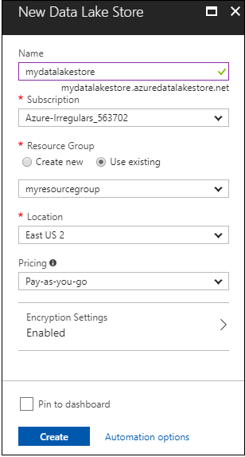

* A resource group is a container that holds related resources for an application, Select an existing resource group, or select the Create new option to create one.
* Set encryption as per requirements
* If keys used from an Azure Key Vault to configure encryption on the Data Lake Store account, you must configure access between the Data Lake Store account and the Azure Key Vault account.